Computer Integrated Surgery II

Hanqing Duan – Group 8

2020/04/14

Seminar Paper Summary

**Wearable IMU-based real-time motion warning system for construction workers' musculoskeletal disorders prevention**

Project Overview

Our project is to measure surgeon’s neck flexion angle accurately during traditional and endoscopic thyroid and ear surgery by using two IMUs. Specifically, we need to calibrate two IMUs’ pitch angle separately against EM tracker. Then, we need to extract pitch angle between two IMUs’ Quaternions for different surgical scenarios, like opening operation and endoscopic operation for thyroid and ear surgery. Lastly, we need to analyze how neck flexion angle changes during these surgeries.

Paper Selection

The paper “Wearable IMU-based real-time motion warning system for construction workers' musculoskeletal disorders prevention” is chosen because it shows high relevance to our project. For example, authors proposed to use two IMUs to measure angle changes which is the same as our method, although they focused on construction workers while we focused on surgeons. Also, the mathematic formula in this paper is clear and helpful for us to learn how to derive angles from two Quaternions. What’s more, I select this paper also because the entire wearable motion warning system that authors implemented. This real-time feedback system gives us idea about how to train young surgeons with right postures.

Problem Statement and Background

In the construction industry, a large percentage of work-related injuries remains to be a major concern and work-related musculoskeletal disorders (WMSDs) are amongst the most frequently reported causes of lost and restrictions. According to this paper, more than 30% workers are suffering these kinds of back and neck pain. Based on risk factor analysis, one of the important factors that induces injuries is that workers spend lots of time in insecure operational postures. So, authors want to solve the problem about how to warn works to keep in secure postures proactively.

Some vision-based and wearable sensors system-based method have been used to assess ergonomic hazard in previous. But system based on IMU sensors shows its advantages on recording human postures holding time in a more precise and reliable way, as well as addressing the limitations of vision-based methods, like suffering from occlusion.

Also, considering the high prevalence of WMSDs around lower back and neck and their costly work-loss and healthcare expenditure in the construction industry, as well as the harsh and complex on-site environment, early awareness and management of potential lower back and neck pain is the best approach to preventing the disorders.

Key Result and Significance

Overall, in order to solve this problem, authors developed a real-time motion warning personal protective equipment. This equipment could enable workers’ self-awareness and self-management of ergonomically hazardous operational pattern for the prevention of WMSDs without disturbance and distraction in operations. Also, this equipment is implemented by two wearable IMUs and an APP.

Method

Specifically, this equipment system contains three parts (shown in the following figure).

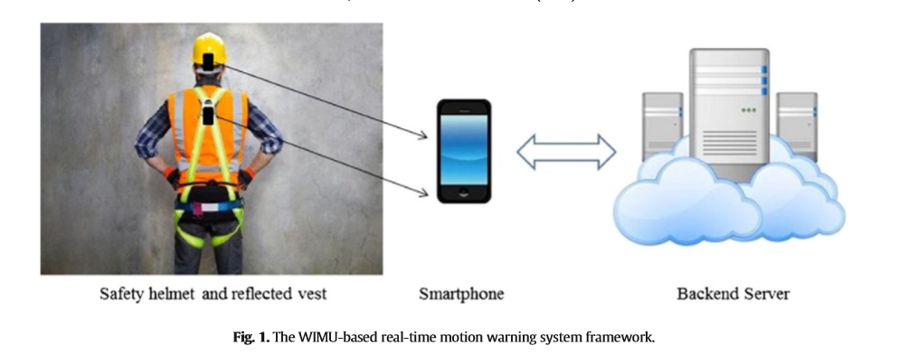

Two IMUs are stabilized on the back of works’ head and back. They could send data back to a smartphone by using Bluetooth. Then an application in smartphone was developed to receive raw data from IMUs and do data processing. What’s more, all operational motion posture data received and processed will be transferred to safety management database in the backend server through site Wi-Fi. A large quantity of on-site practical operational motion data would enable us to accurately assess individual ergonomic hazard level, which will contribute significantly to on-site safety management and individual ergonomic training.

For data processing, the reference position is defined as shown below. The inclination angles of head and trunk are defined as the relative displacement angle of H1–H2 and T1–T2 around point H1 and T1 respectively.

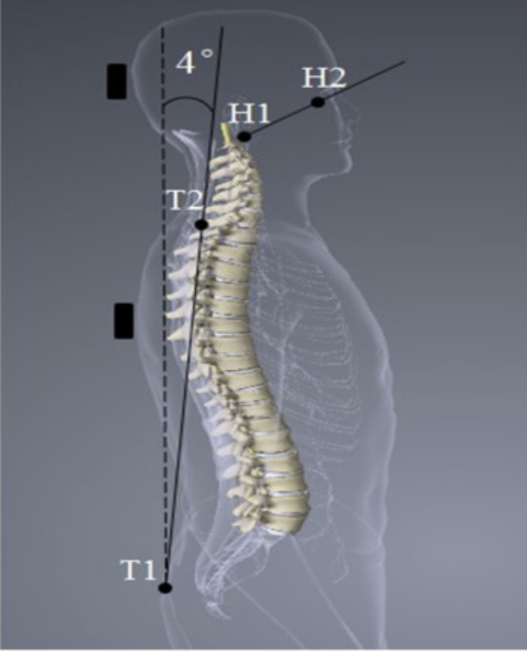

Then, three different angles (shown below) are calculated based on the following formula.

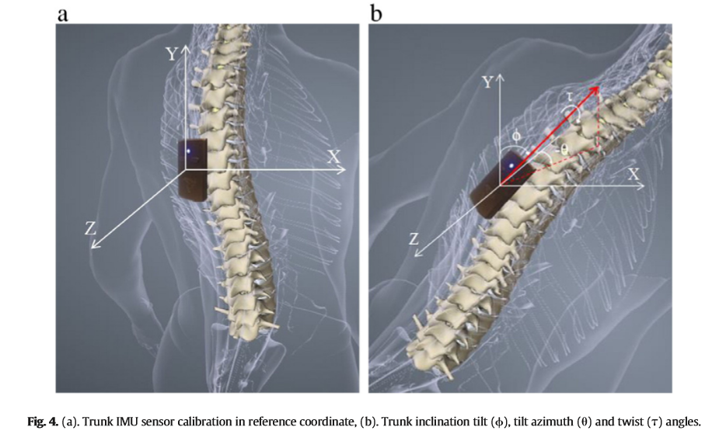

If two normalized Quaternions acquired from two IMUs are q1 and q2 respectively, unit vector in a quaternion format with w=0 along Y-axis is p1, and a negative unit vector along Z-axis is p2, then according to the multiplication formula of quaternions, p’=q*p*inv(q), we could get the coordinates after rotation of both p1 and p2 as following.

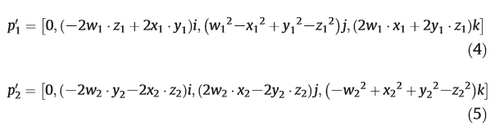

Then, we could get three different angles be following equations below.



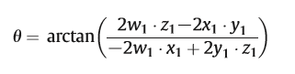

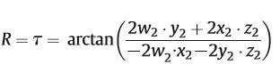

For warning system, a good threshold is important. The maximum acceptable holding time and insecure angle of inclination are shown below.

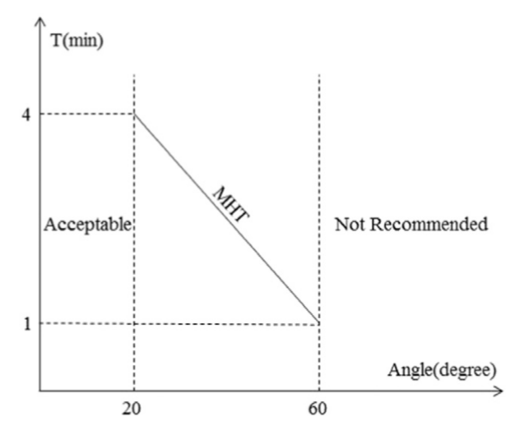

The ‘Acceptable’ zone indicates that a worker's angle inclination during operation is safe. The ‘Not Recommended’ zone represents a high risk of lower back pains once the angle inclination is over 60° during operations. Between the ‘Acceptable’ and the ‘Not Recommended’ zone, a function indicating the quantitative relationship between holding time (min) and static angle (degree) of trunk inclination is suggested. And nth frame with an output frequency f = 1/T can be approximately calculated as follows.

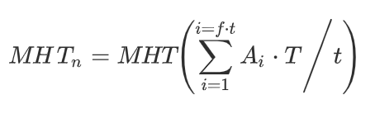

Then, if t > MHT(A), the APP will warn.

Results

From the experiment result (shown below), we could see head and neck angle changes could be detected and displayed on the App. Once the worker changes his posture after warning, the warning will cancel. So, we could say this system is a meaningful, useful, cost-effective, suitable system for construction operations.

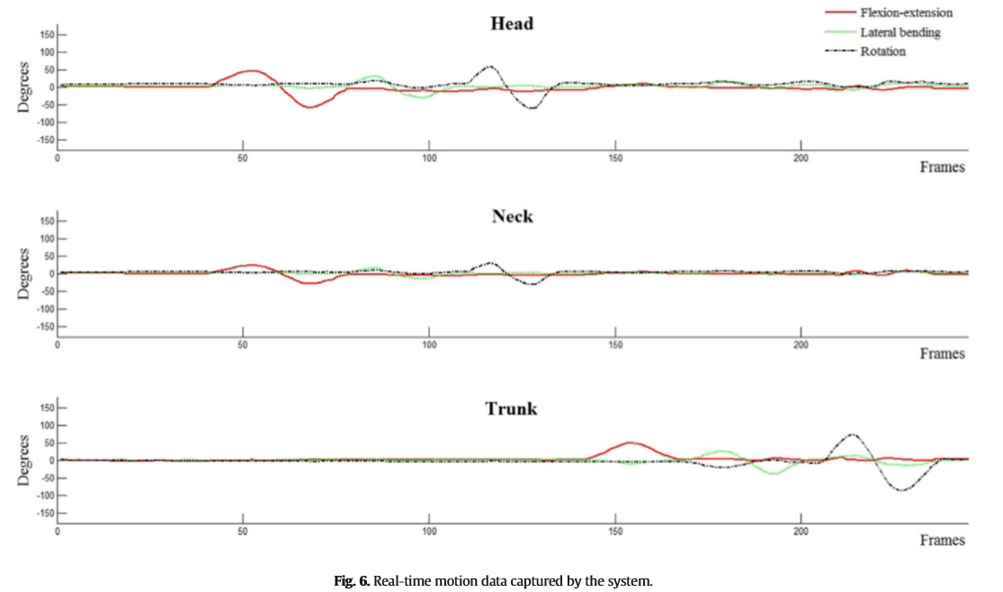

Also, authors proposed several future works, including adding a solar charger into each IMU to extend working hours, developing advance algorithms to improve accuracy of captured body segments.

Overall Assessment

Overall, this is a good paper for us. There are several pros:

1. it implemented a real-time warning system for workers which could help workers keep postures correct.

2. it contains clear mathematical formula about how to get angle between two Quaternions.

3. it collect data to backend server to improve analysis accuracy.

However, there are also some cons:

1. it didn’t talk about IMUs’ calibration details.

2. it didn’t talk about how to improve analysis accuracy by using feedback data on backend server.

This paper is also useful for our project.

1. We learned how to calculate angles between two Quaternions from this paper and used the formula when we did calibration.

2. This motion warning system also could be used to notice surgeons’ wrong position and to train young surgeons with right operating postures in time.

Reference

Yan, Xuzhong, et al. "Wearable IMU-based real-time motion warning system for construction workers' musculoskeletal disorders prevention." Automation in Construction 74 (2017): 2-11.